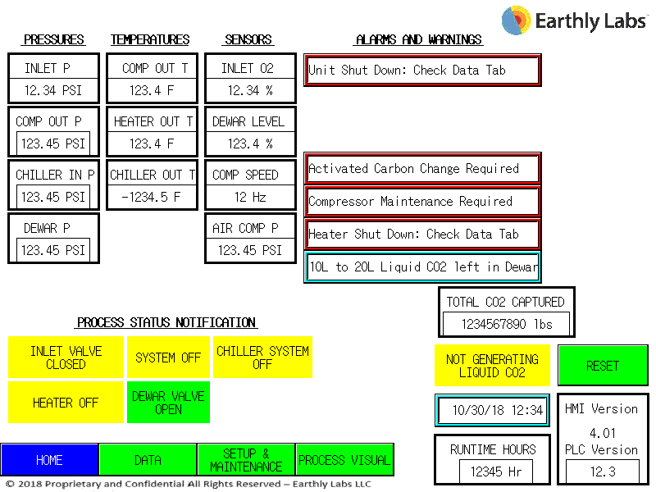
1
O2 GOOD INLET VALVE OPEN
SYSTEM ON
CHILLER SYSTEM ON
3
2
113.5 psi
15/22/30/60

200.0lbs
0.0-0.9%
140.5 F
450.0 F
-35.1 F
145 – 150 psi
150 – 155 psi
155 – 160 psi

0.5 – 3.5 psi

